bittner,hale-1996-the structural determination of case and agreement.pdf

Chomsky (1981) introduced the term “structural Case” for abstract Case which is predictably
assigned, under government at s-structure, by heads of certain syntactic categories.

structural
Case assigners were identified as heads of [-N] categories: V, P, or finite I (Chomsky 1980,
1981, 1986a). In more recent work (Chomsky 1989, 1992), the relevant categories have
been taken to be members of the AGR family instead

In this paper, we propose a different
theory, where the category is not even relevant to this issue. What matters instead
are the syntactic relations in the government domain of the head. These relations
determine whether the head stands in a syntactic relation which we refer to as “Casebinding”
to any argument. The universal prediction of this theory is that any head, regardless of its category, will assign a marked structural Case—i.e., accusative, ergative,
or oblique—to any argument which it Case-binds. Otherwise, no marked structural
Case can be assigned. Case-binding also constrains the unmarked structural Case—i.e.,
the nominative—which we analyze as Case-less. For a nominative argument, the constraint
is that it must not be Case-bound.

Universally,
then, direct Cases have Case-binders which either are functional themselves or contain
functional heads—specifically, I(NFL) or D. In contrast, a purely lexical Case-binder (e.g.,
antipassive verb) results in a structural oblique Case

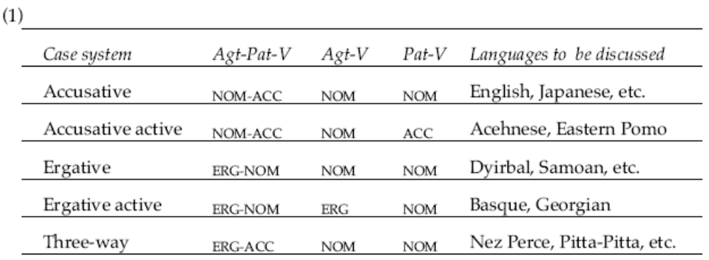

Case, we maintain, represents the maximal extension of the
nominal projection, while C(OMP) represents the maximal extension of the verbal
projection. Thus, a Case-marked nominal is KP, just as a fully extended verbal projection
is CP:

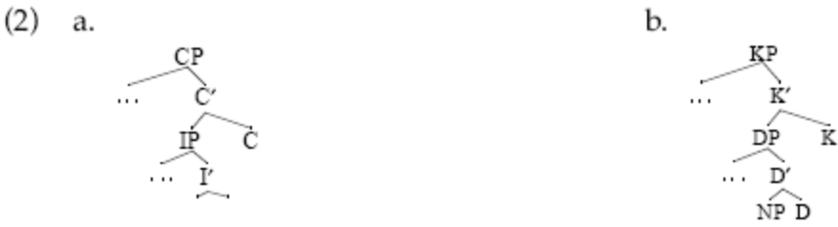

cross-linguistic parallels between “Case drop” and
“Comp drop”

Thus, in Japanese, both the
complementizer te and the accusative Case particle o can be non-overt, but only when
the constituents they head are adjacent to the governing verb

The
marked Case categories, headed by K, embrace two distinct types which we equate with
marked structural Case and inherent Case. 7 Marked structural Cases are underlyingly
empty Ks.

inherent Cases are underlyingly filled Ks.

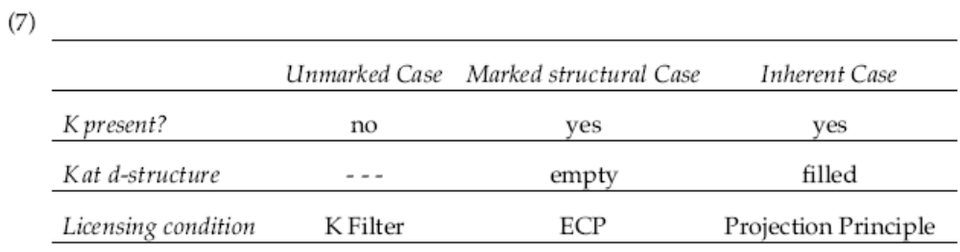

Within this theory, the traditional notion of “Case assignment” can be analyzed as
follows. A head “assigns Case” to an argument, if the structural relation between the
two satisfies the relevant licensing condition. Accordingly, a nominative argument is
assigned Case by the functional head, C or K, which enables it to satisfy the K Filter.
Marked structural Case is assigned by the head which antecedent-governs the corresponding
underlyingly empty K. And inherent Case is assigned by the head which
selects the corresponding underlyingly filled K. On this view, the familiar government
requirement on Case assignment need not be stipulated, since it follows from the independently
motivated licensing conditions.

only lexical heads (i.e., V, P, N, or A) can
assign inherent Case, since only they can select fully extended complements (here, KP).

At s-structure, the empty K is realized by an overt Case-marker provided that it
has an overt DP.

The choice of the Case-marker is determined by the antecedentgovernor
of the empty K—a dependency parallel to that by which the agreement
features of a bound pronoun are determined by its antecedent. The realization conventions
for the direct Cases, ERG and ACC, are given in (9). Both conventions consist of
two parts: a universal core component, concerning the assignment of these Cases by I
and V; and the parametric option of extending the class of possible assigners to a related
category, D or P , respectively. These parameters account for the language-specific
options of extending ERG from transitive subjects to nominal possessors; and of
extending ACC from objects of verbs to objects of prepositions.

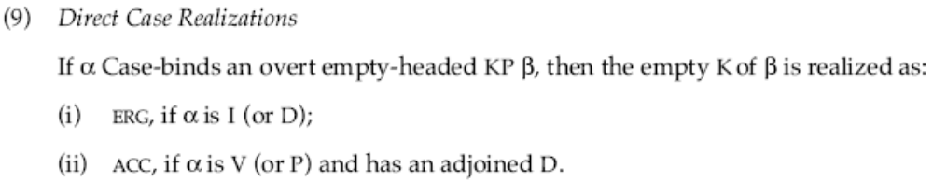

In general, a head will Case-bind
(i.e., assign marked structural Case to) an argument which it locally c-commands, if it
also governs some “Case-competitor” for that argument (cf. Marantz’s 1991 notion of
“dependent Case”). While Case-competitors are regularly K-less nominal elements,
they admit of some variability. As expected, the Case-competitor for an argument may
be a co-argument DP or NP; but it may also be an adjoined head, D or N, functioning as
a “pseudo co-argument”.

For us, as for Williams, a predicate is the
maximal projection of a lexical head (AP, NP, PP, or VP).

The Case-binding
relation crucially requires three elements in a single government domain: a head, an
argument, and a K-less nominal element which activates the head by functioning as a
Case-competitor for that argument.

The Case-binding
relation crucially requires three elements in a single government domain: a head, an
argument, and a K-less nominal element which activates the head by functioning as a
Case-competitor for that argument.

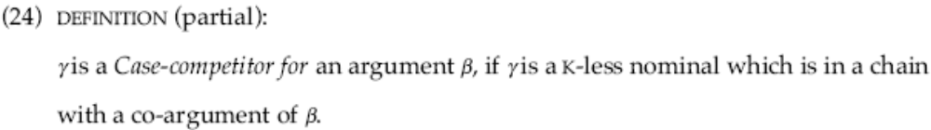

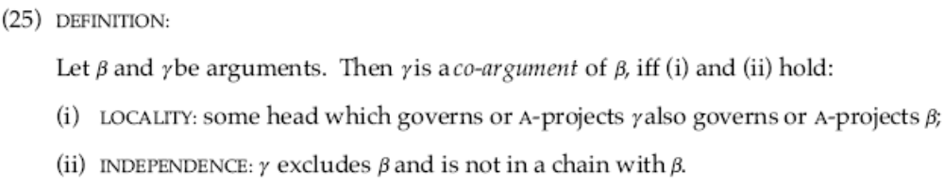

stating the full definition of the relation “Case-competitor”, completing the
partial definition given in (24):

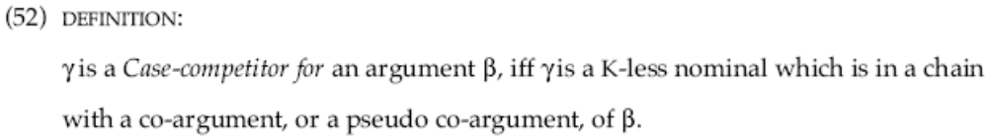

Many languages which employ the ergative Case use it both for the subject of a
transitive VP and the subject of a possessed NP, i.e., the possessor. This holds not only
for classical ergative languages, like Inuit, but also for languages with three-way or split
Case systems

That is, it is also possible for the ergative Case to be assigned only
by I, leaving D to assign some language-specific structural oblique. The latter parameter
setting is exemplified by Hindi, where I assigns the ergative Case, as in (99a,b), but the
structural Case assigned by D is genitive,

unglossed oblique, 99a, glossed as SG in 99c

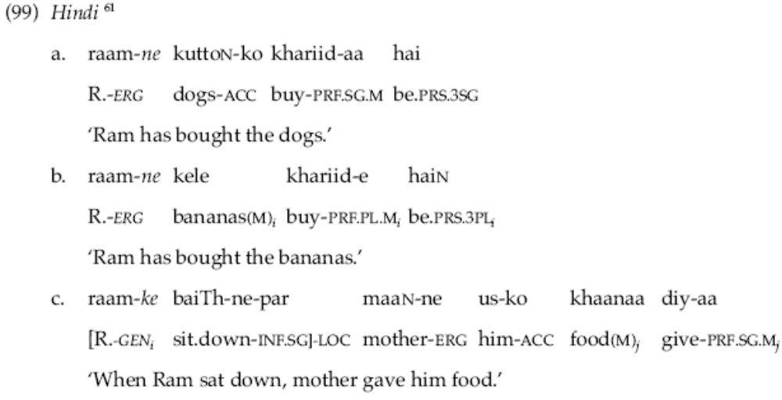
We thank Veneeta Dayal for the data in (99a) and (99b), and for checking (99c), cited by Mohanan
(1990).

marked
structural Case is assigned under a type of antecedent-government, which requires
government and a structural relation we have called Case-binding. Nominative Case is
absence of marked Case, restricted to arguments which are not Case-bound and stand
in the appropriate structural relation to a Case-like head.

Case assignment, as viewed here, is fundamentally a structural matter. Moreover,
we believe its behavior to be determined by structural factors which exist in grammar
quite independently of Case itself.

While our analysis makes reference to technical
definitions of some complexity, most of these are fundamentally the same as definitions
already established in the linguistic literature.

For example, the licensing of nominative,
K-less, arguments involves entirely conventional notions, c-command and government,
that have nothing in particular to do with Case. And the licensing of nominals in
morphologically marked Cases—the category KP, headed by empty K at d-structure—
likewise involves a standard notion, that of antecedent-government, and a universal
principle, the ECP, whose domain of applicability extends far beyond marked structural
Case. In general, a nominal argument will be in a marked structural Case only if it is
Case-bound, since only then will its empty K be able to satisfy the antecedent government requirement of the ECP. If the argument is not Case-bound, then it will be
licensed in the nominative, K-less form, if it meets the provisions of the K Filter. It is the
Case-binding relation whose proper determination involves moderate complexity, and
it is this relation which has occupied a large measure of our attention.

To be sure, this theory is more complex than the idea that structural Case is
assigned by predictable syntactic categories (e.g., [–N] categories, as in Chomsky 1980,
1981; or AGR categories, as in Chomsky 1989, 1992). However, there are some
advantages to our strictly relational view of structural Case assignment. First,
parametrization is limited to the morphological realization of marked structural Case
categories and is not involved in the issue of whether or not structural Case is assigned.
Second, for the direct Cases ACC and ERG even the realization conventions are essentially
universal. Third, many other Case categories, heretofore thought to be “quirky” or
idiosyncratic, are assimilated to the category of marked structural Case, being
predictably assigned under government and Case-binding and differing only in respect
to their morphological realization.

Nevertheless, we predict a non-trivial correlation between pronominal
agreement and the direct Cases (NOM, ACC, ERG). This follows, because pronominal
agreement necessarily involves canonical antecedent government (i.e., government and
the conventional binding relation) between a functional head and a nominal argument.
Unlike structural obliques, nominal arguments in the direct Cases are always governed
by functional heads.

Marantz, A. (1991) “Case and Licensing,” ESCOL.
Mohanan, T. (1990) Arguments in Hindi, Doctoral dissertation, Stanford University,
California.

